*Astronomical Data Analysis Software and Systems XV ASP Conference Series, Vol. XXX, 2005*

arXiv:astro-ph/0510844v1 31 Oct 2005

*C. Gabriel, C. Arviset, D. Ponz and E. Solano, eds.*

Massive Science with VO and Grids

Robert Nichol1

*Institute of Cosmology and Gravitation (ICG), Univ. of Portsmouth, Portsmouth, PO1 2EG, UK*

Garry Smith2

*Institute of Astronomy, School of Physics, University of Edinburgh, UK.*

Christopher Miller

*Cerro-Tololo Inter-American Observatory, NOAO, Casilla 603, LaSerena, Chile*

Peter Freeman, Chris Genovese, Larry Wasserman,

*Dept. of Statistics, Carnegie Mellon University, Pittsburgh, PA-15213, USA*

Brent Bryan, Alexander Gray3, Jeff Schneider, Andrew Moore

*School of Computer Science, Carnegie Mellon University, Pittsburgh, PA-15213, USA*

Abstract. There is a growing need for massive computational resources for the analysis of new astronomical datasets. To tackle this problem, we present here our first steps towards marrying two new and emerging technologies; the Virtual Observatory (e.g, AstroGrid) and the computa- tional grid (e.g. TeraGrid, COSMOS etc.). We discuss the construction of *VOTechBroker*, which is a modular software tool designed to abstract the tasks of submission and management of a large number of compu- tational jobs to a distributed computer system. The broker will also interact with the AstroGrid workflow and MySpace environments. We discuss our planned usages of the *VOTechBroker* in computing a huge number of n–point correlation functions from the SDSS data and mas- sive model-fitting of millions of CMBfast models to WMAP data. We also discuss other applications including the determination of the XMM Cluster Survey selection function and the construction of new WMAP maps.



1 Email: [bob.nichol@port.ac.uk](mailto:bob.nichol@port.ac.uk)

2 ICG, Univ. of Portsmouth, Portsmouth, PO1 2EG, UK

3 Georgia Tech College of Computing, 801 Atlantic Drive, Atlanta, UK

1

1. Introduction

Over a petabyte of raw astronomical data is expected to be collected in the next decade (see Szalay & Gray 2001). This explosion of data also extends to the vol- ume of parameters measured from these data including their errors, quality flags, weights and mask information. Furthermore, these massive datasets facilitate more complex analyses, e.g. nonparametric statistics, which are computationally intensive. A key question therefore is: Can existing statistical software scale- up to cope with such large datasets and massive calculations? We address this question here by focusing on two exciting new technologies, namely the Virtual Observatory (VO) and computational grids.

1. N–point Correlation Functions

As a case study of the types of massive calculations planned for the next gener- ation of astronomical surveys and analyses, we discuss here the galaxy n-point correlation functions. These have a long history in cosmology and are used to statistically quantify the degree of spatial clustering of a set of data points (e.g. galaxies). There are a hierarchy of correlation functions, starting with the 2- point correlation function, which measures the joint probability of a data pair, as a function of their separation *r*, compared to a Poisson distribution,

*dP*12 = *N* 2*dV*1 *dV*2(1 + *ξ*(*r*))*,* (1)

where *dP*12 is the joint probability of an object being located in both search volumes *dV*1 & *dV*2, and *N* is the space density of objects. *ξ*(*r*) is the 2-point correlation function and is zero for a Poisson distribution. If *ξ*(*r*) is positive, then the objects are more clustered on scales of *r* than expected, and vica versa for negative values. The next in the series is the 3-point correlation function, which is defined as,

*dP*123 = *N* 3*dV*1 *dV*2 *dV*3(1+*ξ*12(*r*12)+*ξ*23(*r*23)+*ξ*13(*r*13)+*ξ*123(*r*12*, r*23*, r*13))*,* (2)

where *ξ*12*, ξ*12*, ξ*12 are the 2-point functions for the three sides (*r*12*, r*23*, r*13) of the triangle and *ξ*123 is the 3–point function. Likewise, one can define a 4-point, 5- point etc., correlation function. The reader is referred to Peebles (1980) for a full discussion of these n-point correlation functions including their importance to cosmology (see also the recent lecture notes of Szapudi 2005). We also refer the reader to Landy & Szalay (1993) and Szapudi & Szalay (1998) for a discussion of the practical details of computing the N–point functions.

Naively, the computation of the n–point correlation functions scale as *O*(*Rn*), where *R* is the number of data–points in the sample. As one can see, even with existing galaxy surveys from the Sloan Digital Sky Survey (SDSS), where *R* ∼ 106–107, such correlation functions quickly become untractable to compute. In recent years, there has been a number of more efficient algorithms developed

to beat this naive scaling. For example, the International Computational As- trostatistics (inCA; www.incagroup.org) group has developed a new algorithm based on the use of the multi–resolutional KD-tree data structure (mrKDtrees).

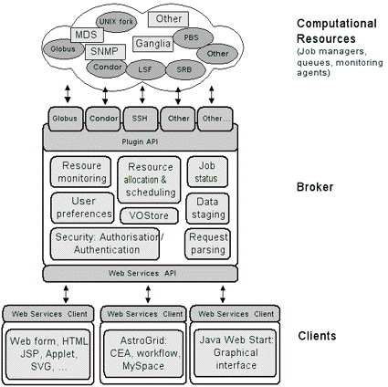

Figure 1. The archtecture of the VOTechBroker

This software, known as *npt*, is publicly available (www.autonlab.org), and has been discussed previously in Gray et al. (2003), Nichol et al. (2001) and Moore et al. (2000). Briefly, mrKDtrees represent a condensed data structure in mem- ory, which is used to efficiently answer as much of any data query as possible, i.e., pruning the tree in memory. The key advance of our *npt* algorithm is the use of “n” trees in memory together to compute an n–point function.

1. Computing Correlation Functions

Even with an efficient algorithm, the computation of higher–order correlation functions is intensive. In detail, the n–point correlation functions require a large number of sequential calls to the *npt* code. These include computing the cross–correlation between the real data (called *D*) and a random dataset (called *R*), which is used to mimic the edge effects in the real data. As out-

lined in Szapudi & Szalay (1998), each estimation of a 3–point correlation func- tions, for a given bin of triangle shapes (i.e., *r*12 ± ∆*r*12 , *r*23 ± ∆*r*23 , *r*13 ±

∆*r*13 , requires seven separate source counts over the whole dataset, namely

*DDD, DDR, DRR, RRR, DD, RR, DR*. Therefore, if one wished to probe ∼ 102 triangle configuration, then ∼ 103 sequential *npt* jobs are required, each of which could take several minutes to run. This can rise rapidly if one wishes to

estimate errors on the n–point functions using either jack-knife resampling (i.e., removing subregions of the data and then re-computing the correlation func- tions), or a large ensemble of mock catalogs (derived from simulations). Such computations are well-suited to large clusters or grid of computers.

In recent years, we have used resources like TeraGrid (www.teragrid.org) and COSMOS ([www.damtp.cam.ac.uk/cosmos/)](http://www.damtp.cam.ac.uk/cosmos/)) to perform the computation of the n–point correlation functions for the SDSS main galaxy sample and the SDSS LRG sample. Our experience shows that the management and scheduling of such a large number of jobs on these massive machines is laborious and tedious. To ease this problem, we are working on *VOTechBroker*, which is a tool that joins two new and emerging technologies; the VO and computational grids.

1. VOTechBroker

AstroGrid (www.astrogrid.org) is a PPARC-funded project to create a working Virtual Observatory for UK and international astronomers. AstroGrid works closely with other VO initiatives around the world (via the International Virtual Observatory Alliance; IVOA) and is part of the Euro–VO initiative in Europe. In particular, the work outlined here has been performed as part of the EU– funded VOTech project, which aims to complete the technical preparation work for the construction of a European Virtual Observatory. Specifically, VOTech is undertaking R&D into data–mining and visualization tools, which can be inte- grated into the emerging VO and computational grid infrastructure. Therefore, VOTech will build upon existing or emerging standards and infrastructure (e.g. IVOA standards and AstroGrid middleware), as well as looking at standards from W3C and GGF.

As part of the VOTech research, we are engaged in developing the *VOTech- Broker*. The key design goals of the broker are to: *i)* Remove the execution and management of a large number of jobs (like *npt*) from the user in a trans- parent and reusable way; *ii)* Accommodate different grid infrastructures (e.g. condor, globus etc.); *iii)* Locate suitable resources on the grid and optimize the submission of jobs; *iv)* Monitor the status and success of jobs; *v)* Combine with AstroGrid MySpace and workflow environments to allow easy management of job submission and final results (as well as utilizing other algorithms within the VO). In Figure 1, we show the schematic design of the broker archtecture which illustrates the modular and “plug-in” design philosophy we have adopted. This is required as one of the key requirements of *VOTechBroker* is that it should be straightforward to add new algorithms, resources and middleware (e.g. a different job submission tool or protocol).

We have implemented the core functionality of *VOTechBroker* and are presently testing it by submitting ∼ 104 *npt* jobs on both the UK National Grid Servise (www.ngs.ac.uk), COSMOS supercomputer and a local condor pool of machines. The key ingredients of the present *VOTechBroker* include GridSAM (an open-source job submission and monitoring web servise from the London e-

Science Centre), the UK e-Science X.509 certificates, MyProxy (a repository for

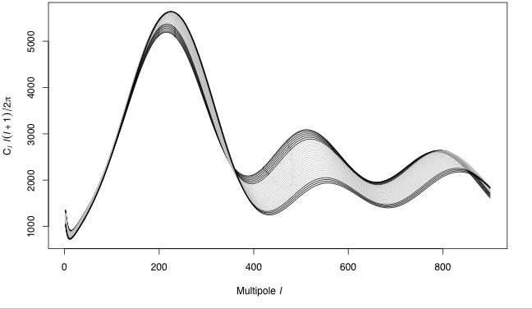

Figure 2. Using CMBfast, we have varied Ω*b* (baryon fraction) and determined which models lie within the 95% confidence ball around *f* (*Xi*). For this illustration, we have kept all other parameters in these CMBfast models fixed at their fiducial values. The gray models are within the confidence ball, while the others are outside the ball indi- cating they are “bad fits” to the data (at the 95% confidence). We get an allowed range of 0*.*0169 *<* Ω*b <* 0*.*0287.

X.509 Public Key Infrastructure security credentials), and the Job Submission Description Language (JSDL; a standard description of job execution require- ments to a range of resource managers from the Global Grid Forum). At present, the *VOTechBroker* provides a web-form interface to just the *npt* algorithm dis- cussed above but is modular in design so other algorithms can be easily added via other web–forms. Results from the *VOTechBroker* will soon be placed in a users AstroGrid MySpace. In the near future, we will interface the broker with other computational resources, e.g., TeraGrid (see below), and the AstroGrid workflow.

1. Nonparametric Statistics

In addition to the need for new statistical software that scales-up to petabyte datasets, we also require new algorithms and computational resources that ex- ploit the emerging power of nonparametric statistics. As discussed in Wasser- man et al. (2001), such nonparametric methods are statistical techniques that make as few assumptions as possible about the process that generated the data. Such methods are more flexible than more traditional parametric methods that impose rigid and often unrealistic assumptions. With large sample sizes, non-

parametric methods make it possible to find subtle effects which might otherwise be obscured by the assumptions built into parametric methods.

In Genovese et al. (2004), we discuss the application of nonparametric techniques to the analysis of the power spectrum of anisotropies in the Cosmic Microwave Background (CMB). For example, one can ask the simple question: How many peaks are detected in the WMAP CMB power spectrum? This ques- tion is hard to answer using parametric models for the CMB (e.g. CMBfast models) as these models possess multiple peaks and troughs, which could poten- tially be fit to noise rather than real peaks in the data. To solve this, we have performed a nonparametric analysis of the WMAP power spectrum (Miller et al. 2003), which involves explaining the observed data (*Yi*) as *Yi* = *f* (*Xi*)+ *ci* where *f* (*Xi*) is a orthogonal function (expanded as a cosine basis *βi*cos(*iπXi*)) and *ci* is the covariance matrix. The challenge is to “shrink” *f* (*Xi*) to keep the number of coefficients (*βi*) to a minimum. We achieve this using the method of Beran (2000), where the number of coefficients kept is equal to the number of data points. This is optimal for all smooth functions and provides valid confidence intervals. We also use monotonic shrinkage of *βi*, specifically the nested sub- set selection (NSS). The main advantage of this methodology is that it proves a “confidence ball” (in N dimensions) around *f* (*Xi*), allowing non-parametric interferences like: Is the second peak in the WMAP power spectrum detected? In addition, we can test parametric models against the “confidence ball” thus quickly assessing the validity of such models in N dimensions. This is illustrated in Figure 2.

1. Massive Model Testing

We are embarked on a major effort to jointly search the 7–dimensional cosmolog- ical parameter–space of Ω*m,* Ω*DE,* Ω*b, τ* , neutrino fraction, spectral index and H0 using parametric models created by CMBfast and thus determine which of these models fit within the confidence ball around our *f* (*Xi*) at the 95% confidence limit. Traditionally, this is done by marginalising over the other parameters to gain confidence intervals on each parameter separately. This is a problem in high-dimensions where the likelihood function can be degenerate, ill-defined and under-identified. Unfortunately, the nonparametric approach is computational

intense as millions of models need to searched, each of which takes ≃ 3 minute to run.

To mitgate this problem, we have developed an intelligent method for searching for the surface of the confidence ball in high-dimensions based on Kriging. Briefly, kriging is a method of interpolation which predicts unknown values from data observed at known locations (also known as Gaussian process regression, which is a form of Bayesian inference in Statistics). There are many different metrics for evaluating the kriging success including variance and en- tropy, yet we employ the “Straddle” method which picks new test points based both on the overall distance from other searched points and are predicted to be near the boundary. We have also developed a heuristic algorithm for searching for “missed peaks” in the likelihood space by searching models along the path jointing already detected peaks. We find no “missed peaks”, which illustrates

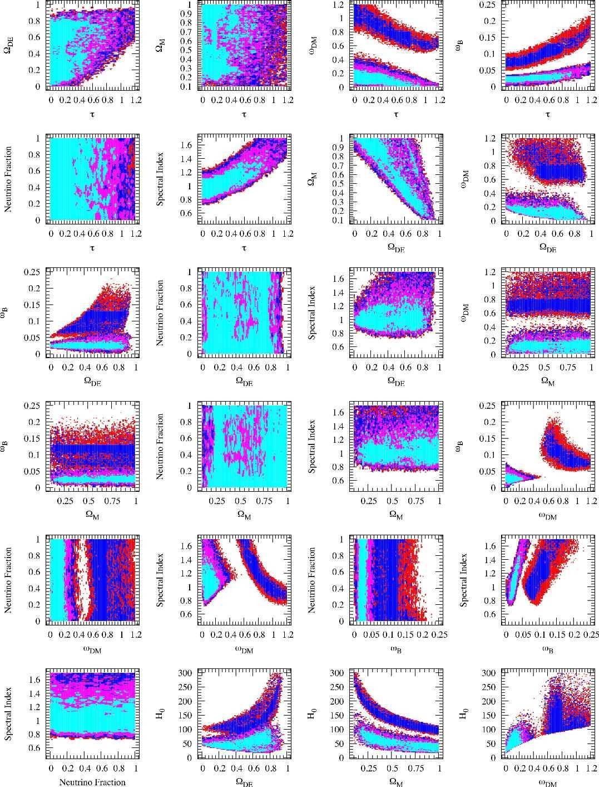

Figure 3. The results of our 7–dimensional parameter search using

1.2 million models from CMBfast. The light blue (or lightest shading for greyscales) color are models excluded at the 34% level. The purple (or mid-grade shading) are models excluded by the 68% confidence ball and the red is the 95% confidence ball

our kriging algorithm is effective in finding the surface of the confidence ball in this high dimensional space.

We have distributed the CMBfast model computations over a local con- dor pool of computers. In Figure 3, we show preliminary results from this high-dimension search for the surface of the confidence ball and present joint 2D confidence limits on pairs of the aforementioned cosmological parameters. These calculations represent 6.8 years of CPU time to calculate over one million CMBfast models. In the near future, we will move this analysis to TeraGrid, using *VOTechBroker*, and plan 10 million models to fully map the surface of the confidence ball. We will also make available a Java–based web servise for access- ing these models, and the WMAP confidence ball, thus allowing other users to rapidly combine their data with our WMAP constraints e.g., doing a joint con- straint from LSS and CMB data. We are also working on possible convergence tests, and visualization tools within VOTech, to access this high-dimensional data.

1. Other Applications

We present here two other examples of where massive computations are needed and could greatly benefit from the *VOTechBroker*. First, the XMM Cluster Survey (XCS) is a project dedicated to uniformily analysing all XMM pointings in search of clusters of galaxies i.e., extended X-ray sources. Dedicated soft- ware has been written to find clusters and a cluster target list created. One of the key components for the cosmological analysis of the XCS is the selec- tion function, which is the efficiency (and therefore, the effective volume of the survey) in finding clusters as function of cluster properties (cluster profile, red- shift, temperature) and observational constraints (exposure time, background etc.). The most comprehensive method of determining such selection functions is via extemsive Monte Carlo simulations i.e., adding fake clusters to the real data and measure the efficiency in re-detecting them (see Adami et al. 2000 for such simulations for the SHARC survey). We estimate that over a million simulations will be required to confidently estimate the XCS selection function because of the large number of parameters involved. This translates to over 4 years of CPU time to complete, but could be trivially parallelized over a large grid of computers using *VOTechBroker*.

Next, we discuss the our independent analysis of the WMAP time-stream data to create CMB maps of the sky (see Freeman et al. 2005). Such independent confirmation is important and allows use to apply the same non-parametric techniques discussed above to the WMAP map-making procedures, and thus assess their effect on the maps and power spectrum analyses. We found small differences between our maps and WMAP (10 microKelvin), which are primary because of the residual dipole uncertainty and second-order terms in the Doppler shift (See Freeman et al. 2005 for details). Each map would take a CPU day on a single processor, but we have parallalized the map-making code to exploit TeraGrid and can make maps in minutes.

1. Summary

We provide here several examples of massive astronomical data analyses that require significant computational resources. Our plan is to develop the *VOTech- Broker* to provide a power framework within which such analyses can be per- formed. As discussed, the main goals of the *VOTechBroker* are to abstract from the user (either a person or another program) the complexities of job sub- mission and management on computational grids, as well as being a modular “plug–in” design so other algorithms and software can be easily added. Finally, we plan to integrate *VOTechBroker* into the AstroGrid workflow and MySpace environments, so it becomes a natural repository for a host of advanced sta- tistical algorithms than scale-up in preparation for petabyte-scale datasets and analyses.

Acknowledgments. We thank all our collaborators and colleagues in inCA, VOTech, AstroGrid, SDSS and VO projects. The work presented here was partly funded by NSF ITR Grant 0121671 and through the EU VOTech and Marie Curie programs. RCN thanks the organisers of the ADASS meeting for their invitation. GS thanks the VOTech and University of Edinburgh for his funding (see eurovotech.org for details).

References

Adami, C., et al., 2000, ApJS, 131, 391

Beran, R., 2000, *J. Amer. Stat. Assoc.*, 95, 155

Genovese, C., *et al.*, 2004, *Statistical Science*, [astro-ph/0410140](http://arxiv.org/abs/astro-ph/0410140)

Gray, A., *et al.*, 2003 *Conference Proceeding for ADASS XIII*, [astro-ph/0401121](http://arxiv.org/abs/astro-ph/0401121) Freeman, P., et al., 2005, ApJ accepted, astro-ph/05xxxx

Landy, S. D. & Szalay, A., 1993, *Astrophysical Journal*, 412, 64 Miller, C. J., *et al.*, 2002, *Astrophysical Journal*, 565, 67.

Moore, A. W., *et al.*, 2000, *Conference Proceeding for “Mining the Sky”*, [astro-ph/0012333](http://arxiv.org/abs/astro-ph/0012333) Nichol, R. C., *et al.*, 2001, *Conference Proceedings for “Statistical Challenges in*

*Modern Astronomy III”*, [astro-ph/0110230](http://arxiv.org/abs/astro-ph/0110230)

Peebles, P. J. E., 1980, *Large-scale structure in the Universe*, Princeton Univer- sity Press

szalay Szalay, A. & Gray J., 2001, *Science*, 293, 2037 Szapudi, I. 2005, [astro-ph/0505391](http://arxiv.org/abs/astro-ph/0505391)

Szapudi, I. & Szalay, A., 1998, *Astrophysical Journal*, 494, 41.

Wasserman, L., *et al.* 2001, *Conference Proceedings for “Statistical Challenges in Modern Astronomy III”*, [astro-ph/0112050](http://arxiv.org/abs/astro-ph/0112050)